Micro Goals – Secure Goal Management Backend API

Introduction

Project Title: Micro Goals – Secure Goal Management Backend API

Team Leader: Keerthana O (Backend Developer)
Team Members:
Mohanapriya K (DataBase Manager)
Ramya V K (Documentation)
Sindhuja R (Demo Video)
Suguna G (Api Tester)
Project Overview:
Micro Goals is a secure backend API created using Node.js, Express.js, and MongoDB. It allows users to create an account, log in, and manage their personal goals. Users can add, view, update, and delete their goals using CRUD operations.
The system uses JWT (JSON Web Token) authentication to keep user data secure. Middleware is used to make sure that only logged-in users can access their own data.
Main features of the system:
- User Registration and Login
- Secure Authentication using JWT
- Create, Read, Update, and Delete Goals
- Protected Routes for security
- Centralized Error Handling
Objective:
The main aim of this project is to build a secure and scalable backend system that helps users manage their goals digitally.
Project Instruction:
The project is built using REST API principles to organize and manage the API properly.
JWT (JSON Web Token) is used to handle user authentication and security.
MongoDB is used to store and manage the data in the database.
The APIs are tested using Thunder Client to check if they work correctly.
The project is designed using the MVC (Model–View–Controller) architecture to keep the code organized and easy to manage.
Pre-requisites:
Before running the project, you need the following tools:
Node.js (version 18 or higher) to run the JavaScript code.
Express.js to build the backend server.
MongoDB (Local or Atlas) to store the project data in a database.
VS Code to write and edit the project code.
Thunder Client (VS Code extension) to test the API requests.
Basic knowledge of JavaScript and REST APIs to understand and work with the project.

Project Architecture Image (Text Representation):
PROJECT ARCHITECTURE:
TECHNICAL ARCHITECTURE
● Runtime: Node.js
● Framework: Express.js
● Database: MongoDB
● Authentication: JWT
● Architecture Pattern: MVC
ER DIAGRAM
Entities:
1. User
_id
name
email
password
2. Goal
_id
title
completed
user Id (Reference to User)
FEATURES:
● User Registration
● Secure Login with JWT
● Create Goal
● Update Goal
● Delete Goal
● View User-specific Goals
● Protected Routes
● Centralized Error Handling
ROLES AND RESPONSIBILITIES:
Role Responsibility
User Register
Login, Manage Goals
USERS FLOW
Sign-up

Delete Goal

Login

Mark Goal as Completed Mark
Create Goal

Retrieve Goal

PROJECT SETUP AND CONFIGURATION
Folder Structure

Micro Goals/
├── middleware/
│ ├── authMiddleware.js
│ └── errorMiddleware.js
├── models/
│ ├── userModel.js
│ └── goalModel.js
├──node_modules /
├──router /
│ ├── authRoutes.js
│ └── goalRoutes.js
├──Schema/
├──utills/
│ ├── genratetoken.js
├──validation/
│ ├── userValidation.js
│
├──-.env
├── Index.js
└──package.json

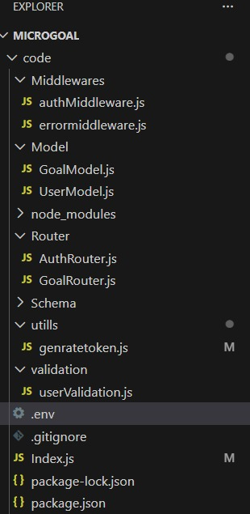

Project Setup

1.Initialize Node.js Project

Command
npm init -y
Purpose
To start and manage the Node.js project.
2. Install Required Dependencies

Command
npm install express mongoose jsonwebtoken bcryptjs dotenv

Purpose
- To add necessary libraries required for backend development.

3. Configure Environment Variables

Create a .env file.
Purpose
- To securely store sensitive information like database URLs and secret keys

4.Start the Server

Command
node index.js
BACKEND DEVELOPMENT
This backend code is the main server file of a Node.js application built with Express and MongoDB. It starts by loading environment variables using dotenv to securely store configuration values such as the server port and MongoDB URL.

The express framework is used to create the web server and handle API requests. mongoose is used to connect the application to the MongoDB database and manage the data models.

The cors middleware is enabled to allow communication between the backend and frontend applications from different origins. Middleware such as express.json() and express.urlencoded() is used to parse incoming request data.

The code also imports custom modules like AuthRouter for authentication-related APIs and GoalRouter for managing goal-related operations. An error-handling middleware is also included to manage application errors effectively.

Overall, this file initializes the server, configures middleware, connects to the database, and sets up the application routes.
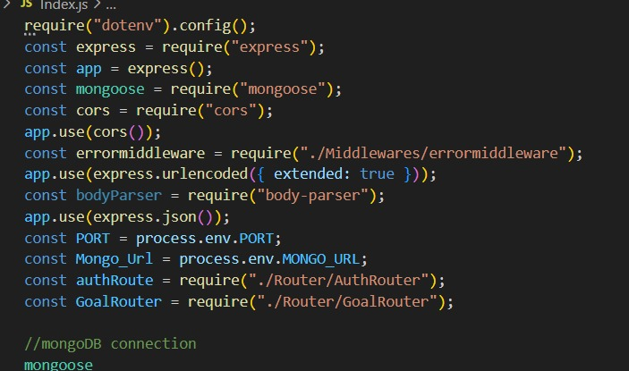
For Connection with MongoDB:-

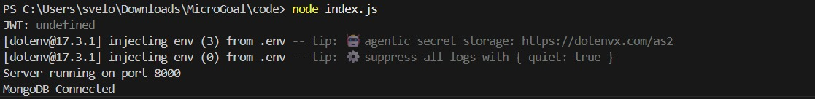

● Connected MongoDB Database
MongoDB was connected to the Node.js application using the Mongoose library. The database connection string was stored in the .env file for security.
● Used Environment Variables
The dotenv package was used to load environment variables such as the MongoDB URI and server port.
● Established Database Connection
When the server starts, Mongoose connects the application to MongoDB using the stored connection URI.
● Connection Verification
After successful connection, the terminal displays a message like “MongoDB Connected”, confirming that the database connection is established.

DATABASE DEVELOPMENT:
CONFIGURE MongoDB
● MongoDB was configured using MongoDB Atlas or Local MongoDB.
● The database connection string was stored in the .env file for security.
CREATE DATABASE CONNECTION
index.js file
● Mongoose was used to connect the Node.js application with MongoDB.
● The mongoose.connect() method establishes the database connection.
● Proper error handling was implemented to manage connection failures
CREATE SCHEMA AND MODELS
User Schema
● The User Schema defines the structure for user data.
● It includes fields such as name, email (unique), and hashed password
Goal Schema (with userId reference)
● The Goal Schema stores information related to user goals.
● Each goal includes a userId reference to link the goal with a specific user.

PROJECT EXECUTION
Project Execution Steps:
- Start MongoDB database.
- Run the backend server.
- Test APIs using Thunder Client.
- Register a new user.
- Login and receive JWT Token.
- Perform Create, Read, Update, and Delete (CRUD) operations on goals.
Project Output Screenshots:
- Successful User Registration (Signup/Login)
In this API call, the user can register a new account or log in to an existing account.
After successful authentication, a JWT token is generated for the user.
Signup:
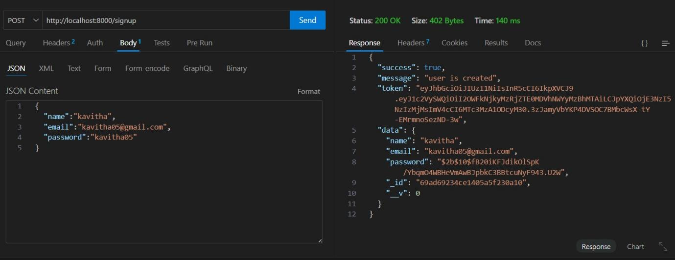
Login:
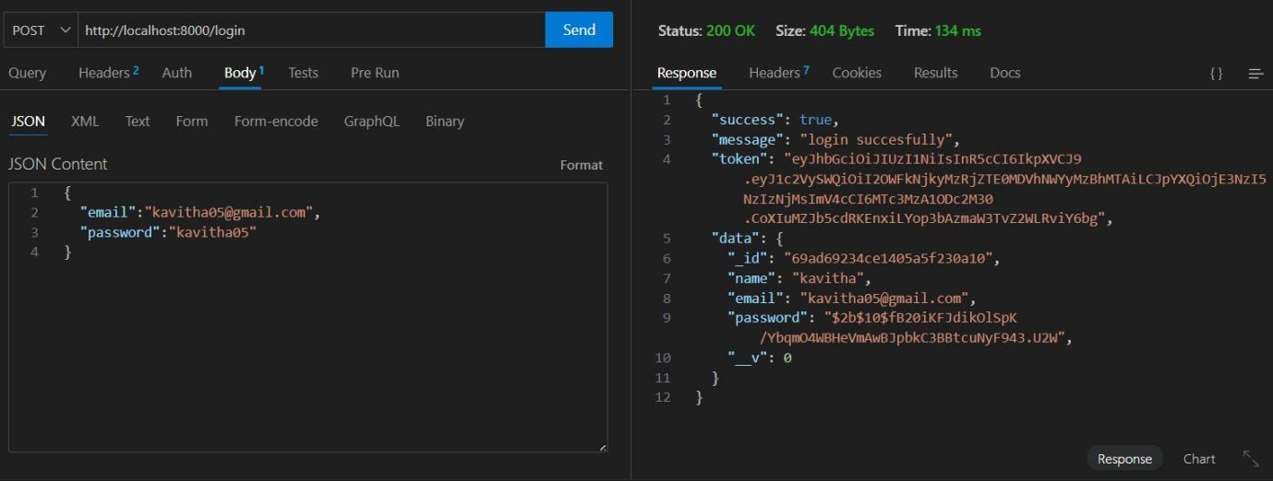

- JWT Token Response
- After the user logs in successfully, the API generates a JWT token.
This token is sent with every request to other APIs to verify the user and allow access to protected routes.
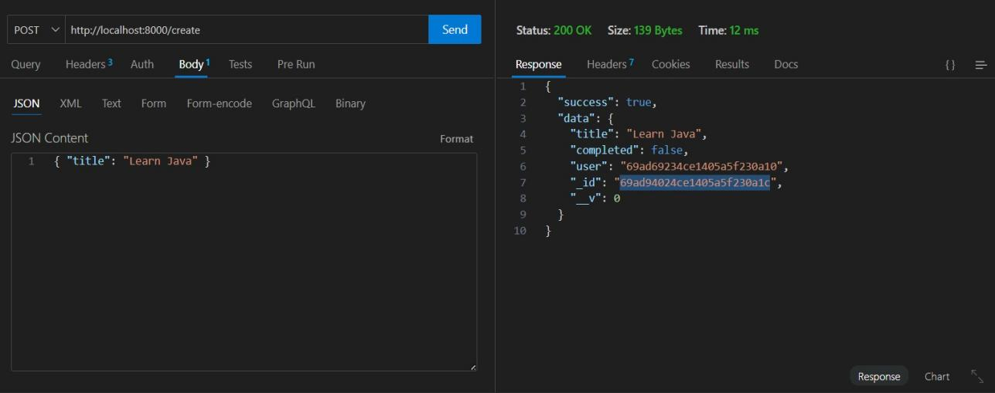

- Goal Created Successfully
- After logging in and receiving the token, the user can send a POST request to the API to create goals.
The created goal is stored in MongoDB, which is used as the database for the application.
- Protected Route Working
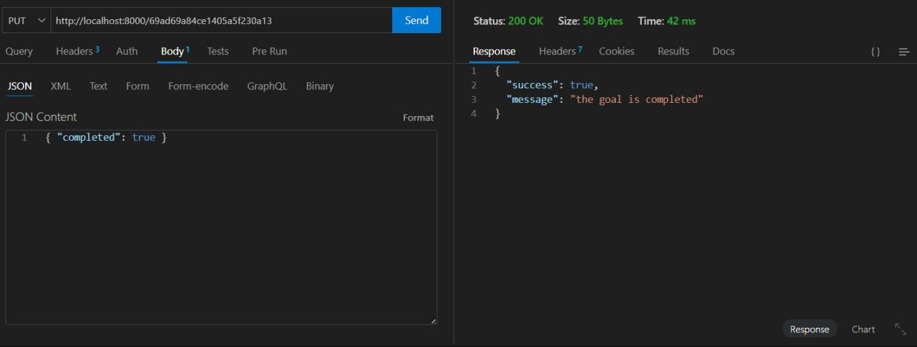
- Protected routes are secured API routes that require authentication.
- If a user does not have the token generated by the backend API, they cannot access the API.
The token must be sent with the request, and the server will verify it before allowing access.
- This helps to protect the routes and ensure that only authorized users can use the API.
- Goal deleted successfully:

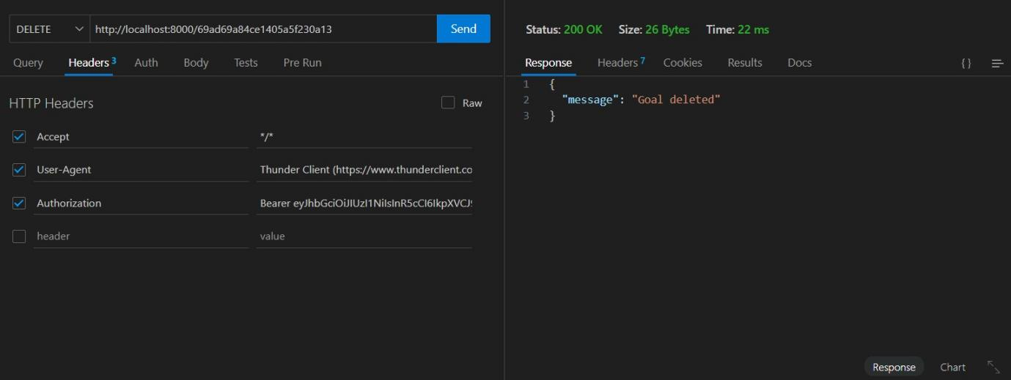

Project Demo Video
- Project Demo Video Record video showing:
- Registration
- Login
- Token usage
- CRUD operations
- Error handling

Demo video link: https://drive.google.com/file/d/1y7ECn7RPPcdG1oV-jnHtyPFH2X3e1QWH/view?usp=drivesdk

